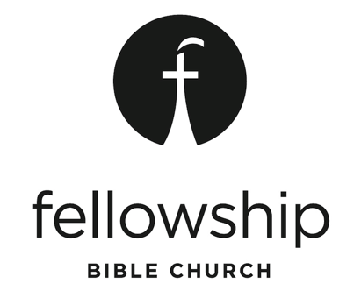

Joshua | BE STRONG AND COURAGEOUS Series
Text: Joshua 9-12; Teaching Pastor / Pat Shivers

For the week of Sunday, April 09, 2017

Opening the Conversation
Have you ever bought something that turned out to be a “lemon”? Share your story. How did you feel? Why is wisdom, or seeking wise counsel, important in life?

The Text: Joshua 9 – 12; (Focal Chapters 9 – 10)

- The Gibeonites deceive Israel into a peace treaty (9:1-15)

  - When we rely on our own understanding we fail to seek the wisdom God has for us.

  - Why is our understanding limited in scope? What is the difference between WISDOM and KNOWLEDGE.

Quote: “Knowledge is proud that it knows so much; wisdom is humble that it knows so little.”

- Israel makes the Gibeonites servants (9:16-27)

  - God can take our failures and use them for His honor and glory

  - Can you think of a personal experience, a failure, that God turned into something honorable?

- Israel must come to the defense of Gibeon (10:1-15)

  - God expects us to honor our commitments even when it's uncomfortable

  - What were some old-fashioned methods of making a commitment? What is required today?

  - Have you ever had to honor a commitment, even though it was inconvenient, or uncomfortable? What was it?

- Israel completely destroys her enemies (10:16-12:24)

  - We can't leave sin lurking in our hearts; we can't play around with sin

  - Have you ever “danced with sin.” What was the price paid? Did it cost you dearly?

  - Quote: “Sin will keep you longer than you want to stay, take you farther than you want to go, and cost you more than you want to pay.”

“Righteousness is more than doing nothing wrong - it's doing something right. It's not just resisting temptation - it's going after God-ordained opportunities. Holiness by subtraction is playing not to lose. Righteousness is going all in with God. It's playing to win. It's living as if the victory has already been won at Calvary's Cross. And it has." – Mark Batterson from his book, IF

